- Open PDF in Adobe Acrobat Pro
- menu Tools :
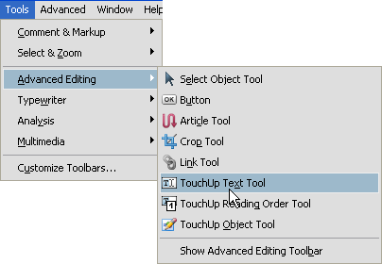
- Click on the text to edit, right click , select Properties...
- Tab Text, click on Fill , select White color, click OK
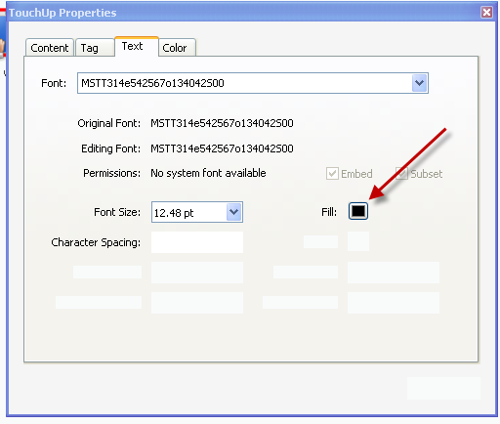
- Click on Select Tool  to exit Touchup Text Tool
- Next need to insert text,
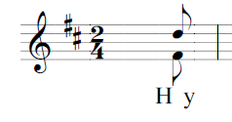
- Menu 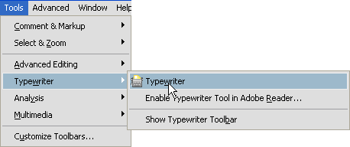
- Then click on place you want to type, start typing.
- Menu 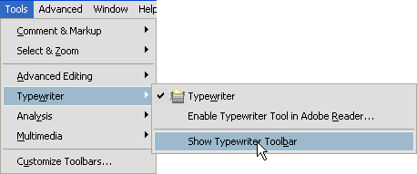
- 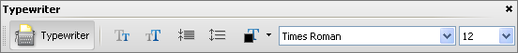
Change font name and font size to match with existing words.
- Save change.

